**Data science – Capstone project**

**Business problem**

Car crashes is the highest cause for accidental deaths and injuries. The Severity of a car accident might be influenced by a number of parameters. The ability to predict the severity could help to prevent future car crashes or reduce their severity.

**Data section**

The label is the incident severity (1 or 2) which are two categories. The rest of the variables are the independent variables. Since there are two categories of severity, I will consider this problem as a classification problem. The independent variables include both numerical and categorical variables. I will use the variable “ADDRTYPE” to investigate the effect of the crash location (block vs intersection) on severity. I found that if a crash is conducted on a block there is 75% its severity is 1 whereas in an intersection it is 56%. I investigated the variable “Location” and found that there are locations with higher frequencies for crashes. Furthermore, there are locations that result in higher change for severe crash (e.g. “10TH AVE E AND E JOHN ST”) and locations that result in higher change for non-severe crash (e.g. “10TH AVE BETWEEN E PIKE ST AND E PINE ST”). From the “severity desc” column, I understand that the difference between the severity levels are “property damage” vs. “injury”. Analysis of the “Collision type” variable shows that different types result in different severities. For example, 90% of “cycle” accident result in severe crashes, while only 10% of “packed car” crashes results on injuries. I will investigate the effect of the day of the week in which the crash happened. I will use the variable “Incdate” and create a new variable “weekday” that captures the day of the week of each crash. I investigated the effect of “junction type” on crash severity and found that some type include high probability for severe crush like “At intersection” while other not like “Ramp junction”. For the value “UNDERINFL” I noticed that the values are N,Y,0,1. I processed the data by changing the 0 to N and the 1 to Y.

**Methodology section**

First, I cleaned the data by removing all rows with missing values. Then I deleted variables (columns) with more than 40% of missing data. I used to “pandas profiling” functions to understand the data, create histogram of each variable and calculate correlations between the variables. I deleted columns, which are Identical to others (full correlation). I balanced the data using an under balancing method. I also standardized the data using the “standardScalar” method. To predict the crash severity I applied various machine learning models including Logistic regression, AdaBoosting, and RandomForest. I split the data into 66% training and 33% test data. I evaluated the models using the following metrics: Accuracy, F1-score, ROC curve.

**Results section**

The confusion metrics of each classifiers are presented here:

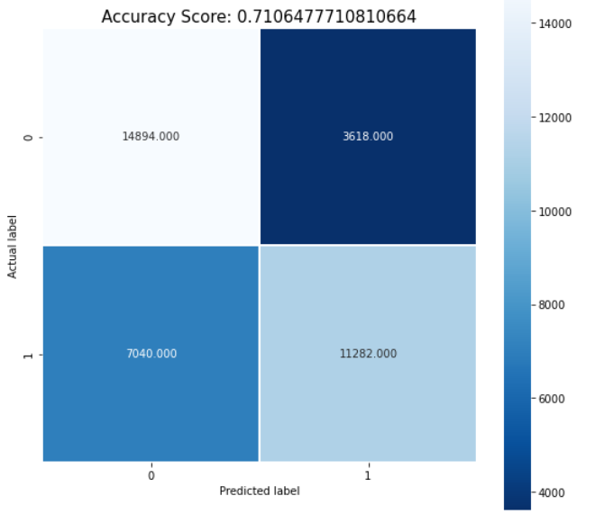 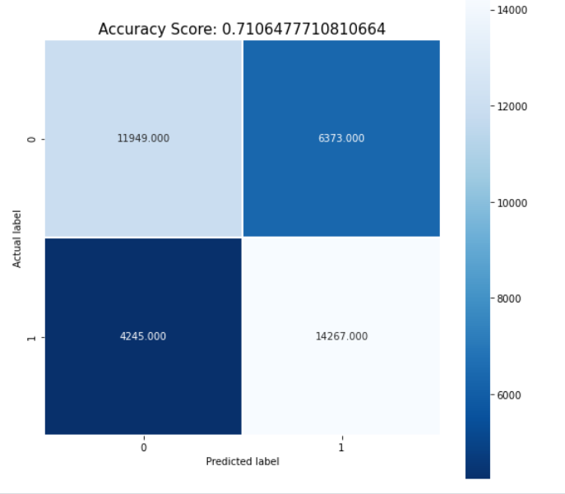 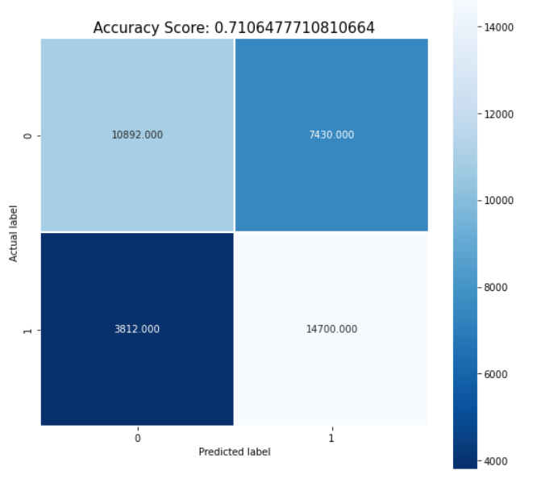

All 3 classifiers (AdaBoost, Logistic, RandomForest) resulted in F1-scores between 0.66-0.71. The Adaboost resulted in the highest score 0.71 while the RandomForest in the lowest 0.66. The Adaboost also resulted in the highest AUC score (0.796) while the RandomForest in the lowest (0.77). Both Adaboost and Logistic regression resulted in accuracy of 0.71 while the RandomForest in accuracy of 0.69. The ROC curves of the 3 methods is presented:

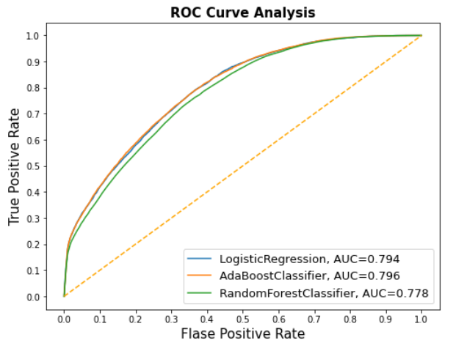

**Conclusion section**

In this report we build a model to predict the severity of an accident based on different variables including the weather, day of week, type of vehicle, location and more. We see that different classifiers resulted in different performance. The Adaboost method resulted in the best performance and in F1-score of 0.71.